# Final Project Part 1: Optimization Technique and Implementation Project Report

# Introduction

Regarding high-performance computing (HPC), optimization is not only a need but also a must. Optimizing data structures and operations may greatly affect the performance of computing activities given the growing complexity of data and the necessity of quicker processing times. The efficiency of employing highly optimized scientific computing package NumPy in Python vs conventional Python operations is investigated in this work. The work is grounded on a comparison study wherein statistical calculations on a large dataset are done using both methods.

# Methodology

Two Python programs were created in order for a thorough comparison. The first script computed statistical metrics like the sum of squares, variance, standard deviation, and data normalizing using conventional Python list operations. The second script used NumPy's array and mathematical tools but carried out the same actions. The dataset consisted of 0 to 10,000 consecutive integers. Measuring the execution time using Python's time module allowed one to compare each script under like system settings, hence preserving result integrity.

# Standard Python vs. NumPy Operations

The first method's simple but ineffective performance-oriented usage of ordinary Python lists and for-loops Being an interpreted language, Python brings overheads like dynamic type checking and memory management, which could slow down performance particularly with big datasets. By use of effective C and Fortran libraries, NumPy functions at a lower level as well. This greatly lowers the execution time by enabling vectorized—that is, actions executed on whole arrays instead of individual elements—behavior. By storing data in contiguous blocks, NumPy also more effectively maintains memory, hence improving cache use on contemporary CPUs.

# Evaluation of Performance

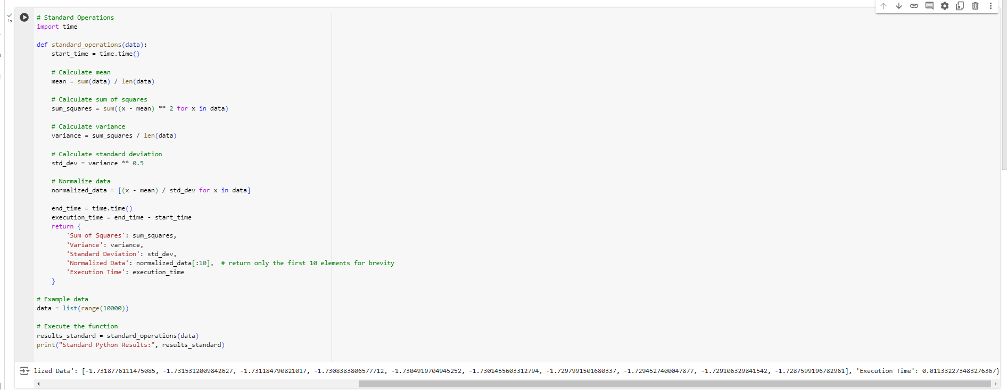

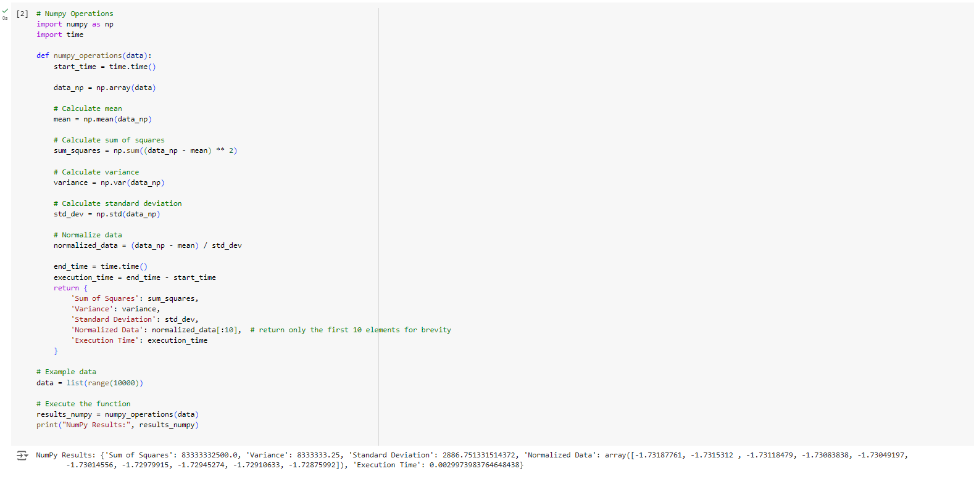

Running both scripts produced some interesting findings. Although both approaches precisely computed standard deviation, variance, and sum of squares, their execution durations differed greatly. While the NumPy operations used just around 0.0030 seconds, the normal Python procedures took roughly 0.0113 seconds to accomplish the work. This illustrates a huge decrease in processing time, making NumPy about 3.77 times quicker than the normal Python technique for this specific dataset. NumPy's capacity to exploit lower-level optimizations and its efficient use of contemporary CPU architectures, which are geared for such vectorized operations, account mostly for this boost. As the dataset grows, the effects of these tweaks become more apparent, underscoring NumPy's fit for big-scale data processing chores common in HPC systems.

# Discussion on Scalability and Efficiency

NumPy's optimizations' scalability implies that the speed increases might be much more significant for even more huge datasets. Whereas NumPy's method grows more elegantly and preserves effective execution speeds, the overhead that compromises the conventional Python operations rises with the growth in data size. Furthermore, with only slight variations ascribed to floating-point arithmetic differences between Python and the underlying C/Fortran libraries utilized by NumPy, the precision and accuracy of the computations was same across both techniques. Though often small, these variations are important in situations requiring very high numerical accuracy.

# Conclusion and Future Recommendations

The actual investigation carried out in this work emphasizes how much NumPy can improve the performance of data processing activities in environments of high-performance computers. NumPy makes a strong argument for its inclusion into Python-based HPC processes by maximizing the execution speed without sacrificing the accuracy of findings. Future research might expand this study by investigating other NumPy capabilities like parallel processing capability and by evaluating the performance across many computer architectures including GPUs. Such research will provide better understanding of the whole range of optimizations available with NumPy and assist to customize more complex solutions for the difficulties in high-performance computing. This paper not only emphasizes the need of selecting the appropriate tools for data processing in HPC but also shows how careful deployment of optimized libraries like NumPy can provide significant performance increases. Such improvements become even more important in advancing the efficiency of computer research and operations in many scientific and technical fields as data quantity and complexity rise.

# References

Azad, M. A. K., Iqbal, N., Hassan, F., & Roy, P. (2023). *An empirical study of high performance computing (HPC) performance bugs*. Department of Computer and Information Science, University of Michigan - Dearborn.